**Logical Volume Manager (LVM)**

1. First check available disks for this lab using lsblk command-

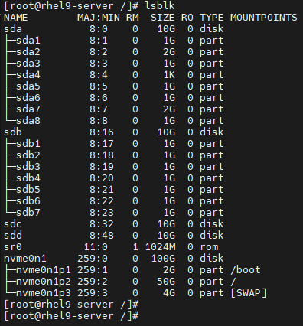

2. Doing this lab using MBR partitioning. Same can be done for GPT as well. Here we need to create two 4GB partitions in disk sdc as sdc1 & sdc2. Keep it primary & change its partition type to LVM using 8e (Hex code or alias) & then list it using lsblk command-

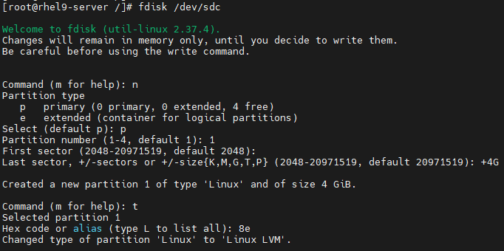

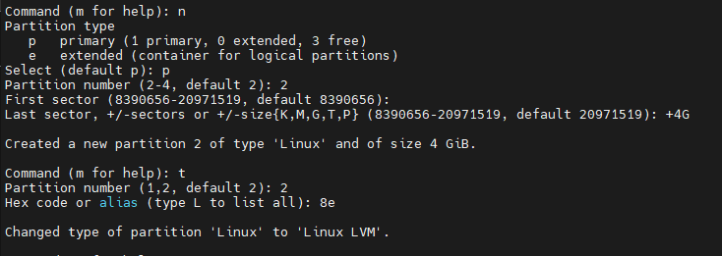

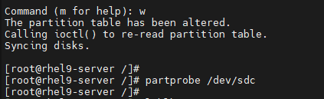

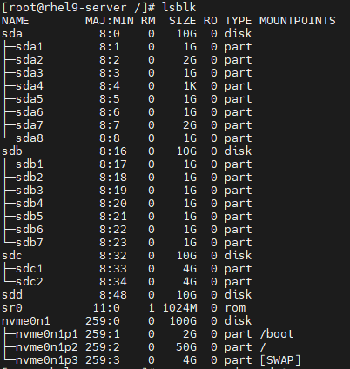

3. Create first physical volume using partition sdc1 & verify it-

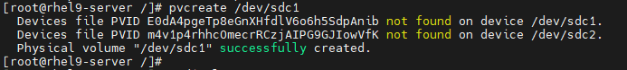

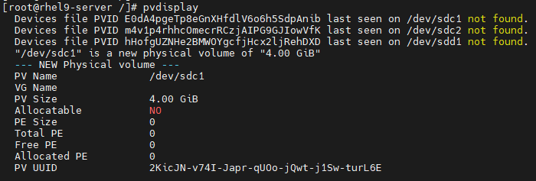

Note: Ignore the “not found” message. This was due to previous lab. It won’t show in yours.

Note: It is showing Allocatable as No, cause this physical volume is not a part of any volume group yet.

4. Create new volume group & verify it-



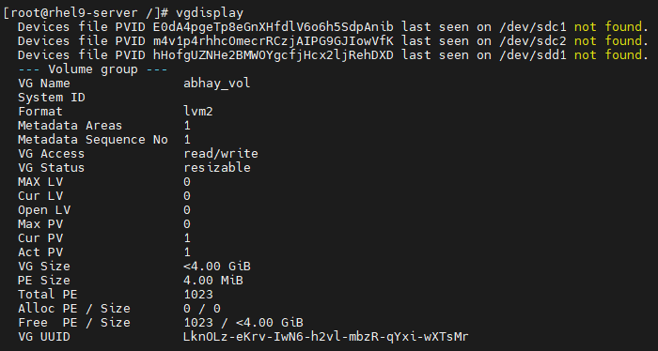

5. Now physical volume created earlier will show allocatable “yes” this time as it is added in newly created volume group-

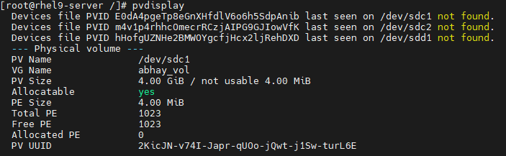

6. We will create two logical volumes “atlantis” & “waikiki” each of 1GB in size-



Note: Ignore this warning. It won’t show in your case.

It is showing detail of atlantis logical volume in below snap.

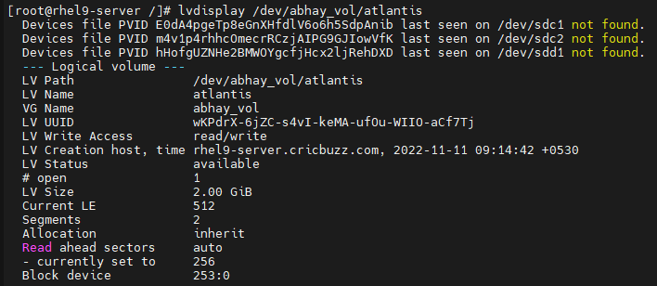

Now, vgdisplay will show available space after creating first volume. It is nearly 3GB left to allocate.

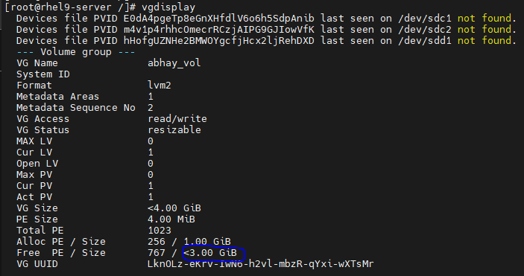

Waikiki LV creation-



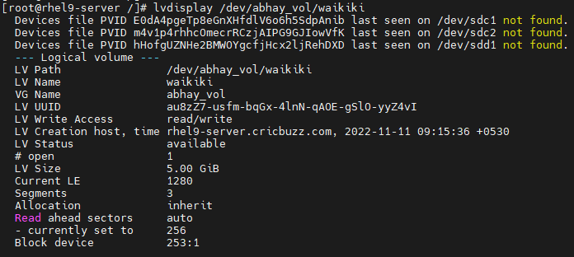

It is showing detail of waikiki logical volume in above snap.

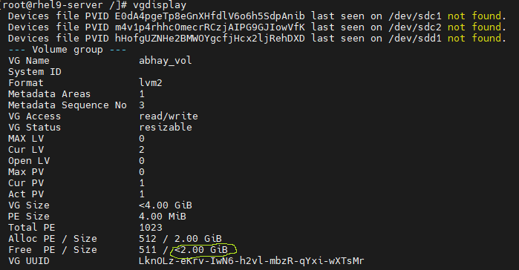

We have nearly 2GB space left after creating both logical volumes.

6. Next, we will format atlantis volume with ext4 & waikiki with xfs file system-

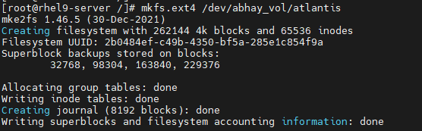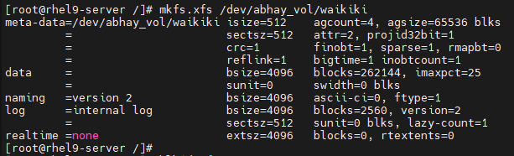

Note: ext4 logical volume can be expand & reduce, but xfs can only expand.

7. Verify created logical volume using lsblk command-

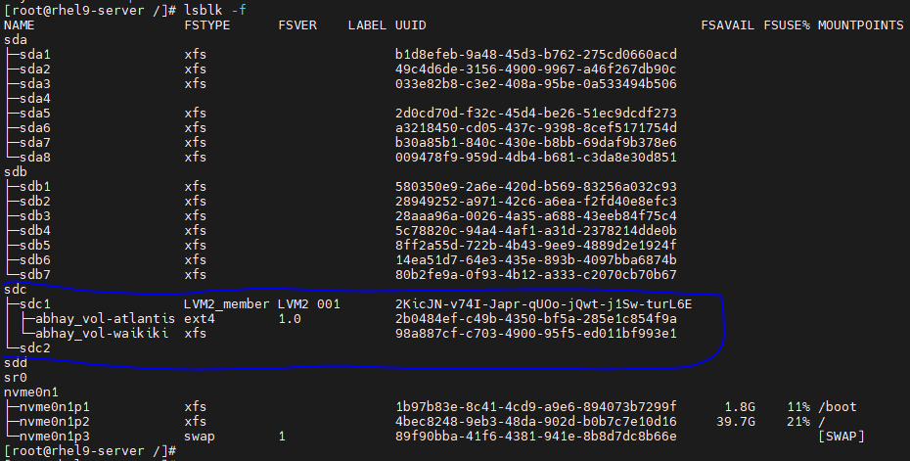

8. Now mount these two logical volumes & add some data in it as shown-



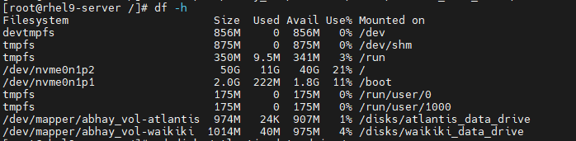

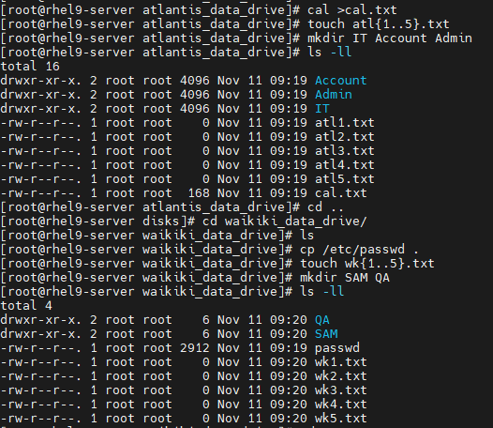

Steps to Extend Logical Volume Size in LVM

1. If we try to extend atlantis logical volume by 2GB, it fails due to insufficient space in volume group-



2. We will add additional partition sdc2 in logical volume abhay_vol to increase its size in order to allocate space to logical volumes-



This physical volume is still unallocated to volume group as shown below-

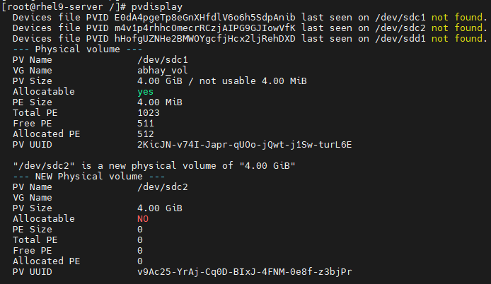

3. To allocate this use command as shown-



Verify it. This will show sdc2 is allocated to volume group-

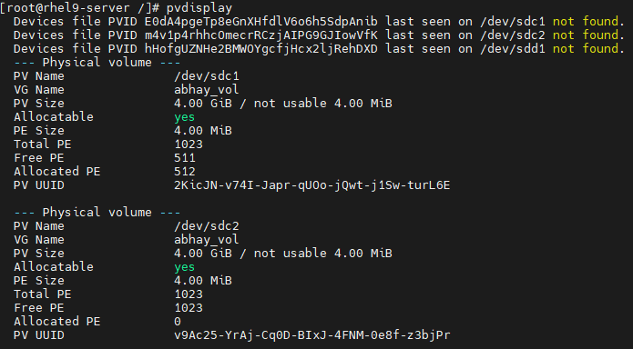

4. Now extend atlantis logical volume size by2GB-



However, it will still show same old volume size-

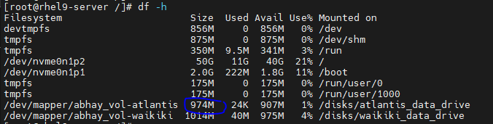

5. To update it, use below command for ext4 file system-

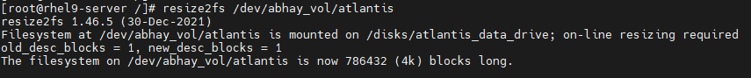

Now it will be updated as shown in snap-

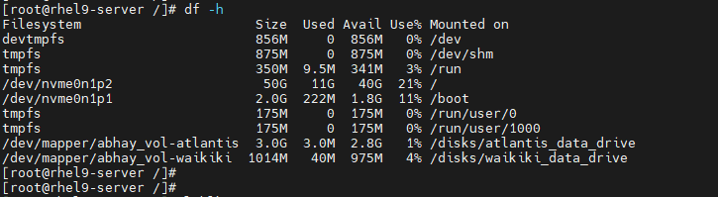

6. In next snap, it shows part of sdc2 partition is used in atlantis logical volume-

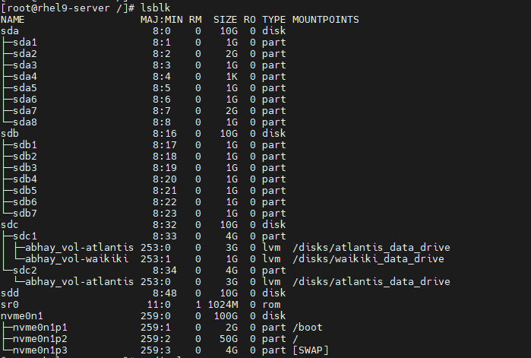

7. Verify remaining space in volume group-

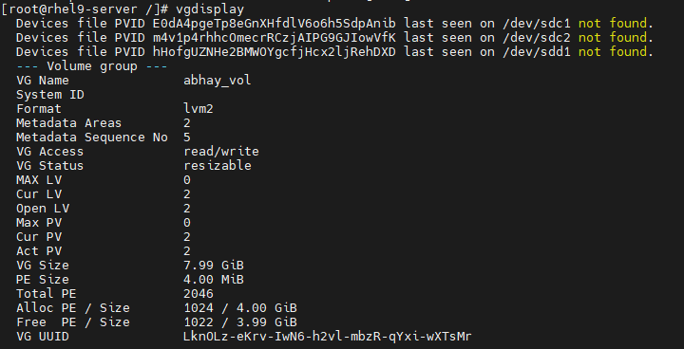

8. Similarly, extend volume size for waikiki logical volume by 2 GB & verify it-



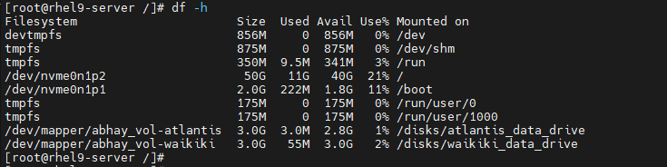

Here increased size is showing as we have used “-r” here. Check remaining volume group size & run lsblk-

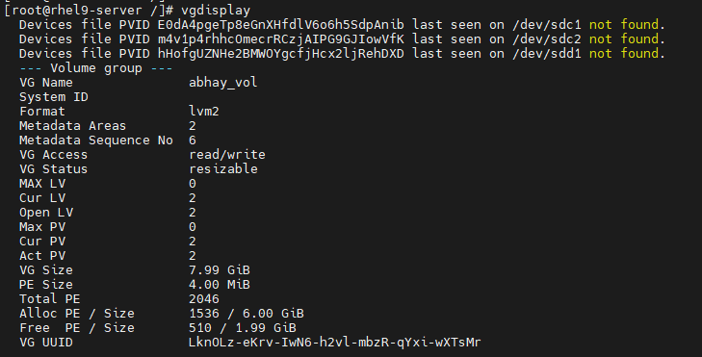

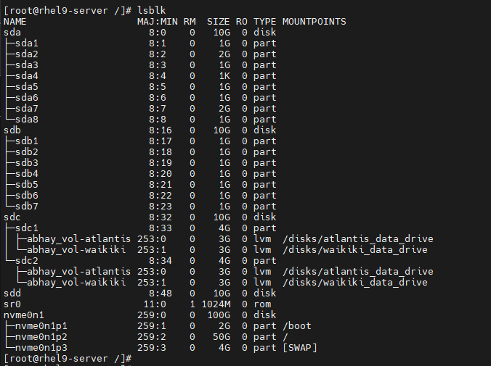

9. Now create new partition sdd1 from newly added disk & verify using lsblk command-

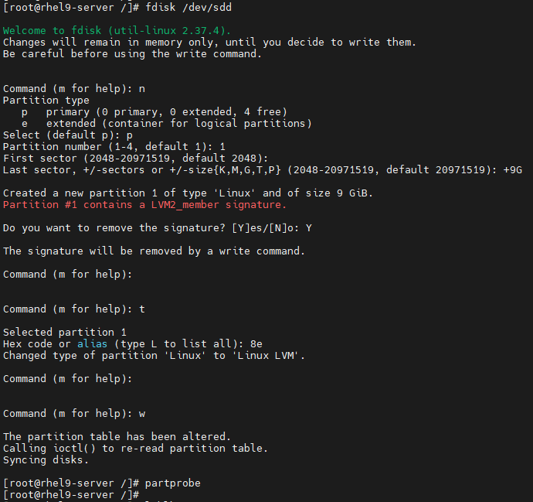

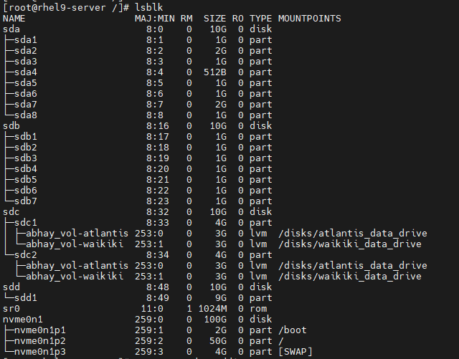

10. Create new physical volume using this /dev/sdd1 partition-



Verify it using pvdisplay. Here it is unallocated as not a part of any volume group-

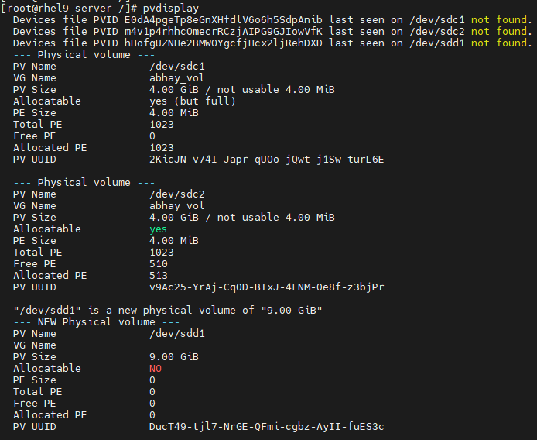

11. Extend volume group using this new physical volume-



Verify new volume group size as shown-

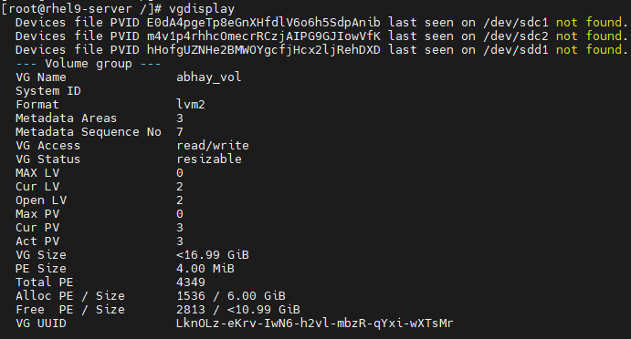

12. Again, extend atlantis logical volume by 2GB-

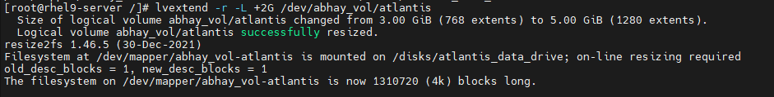

Verify new volume size of atlantis logical volume using df -h command-

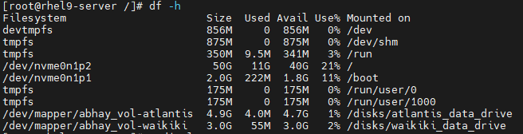

Verify remaining volume space in volume group-

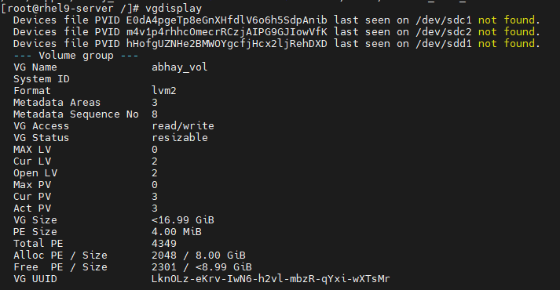

13. Similarly, extend volume size of waikiki volume by 2GB & verify-

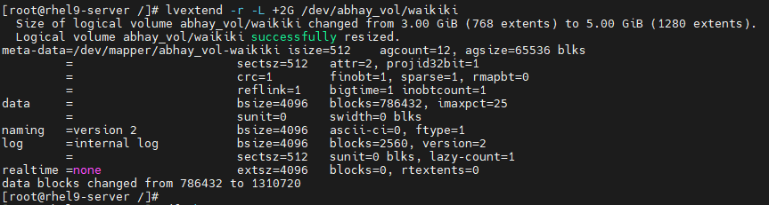

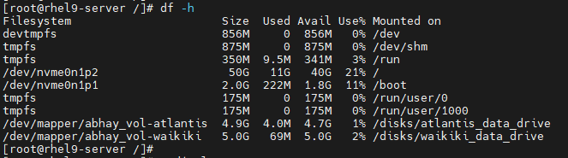

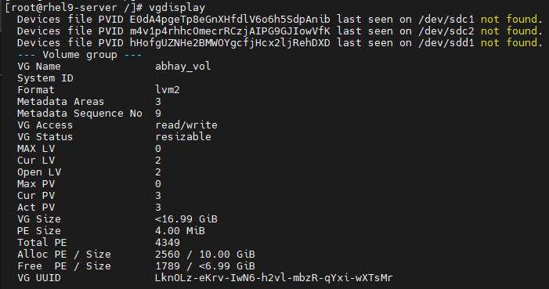

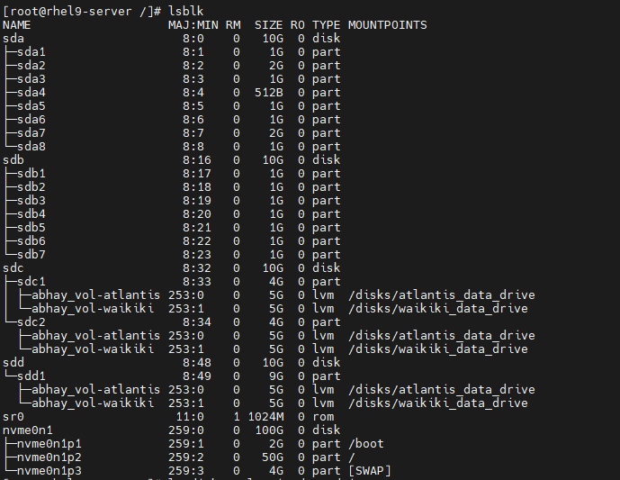

14. List data in atlantis volume after increasing volume size-



Steps to Reduce the Logical Volume size in LVM-

Note: We can’t reduce volume size from xfs file system LV. So, we will do for ext4 (atlantis volume).

1. Take the data backup as it may cause data loss.

2. unmount this atlantis LV & verify using df -h.



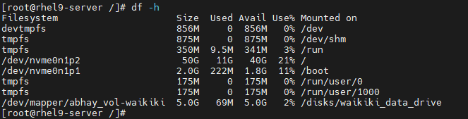

3. Check for file system errors-

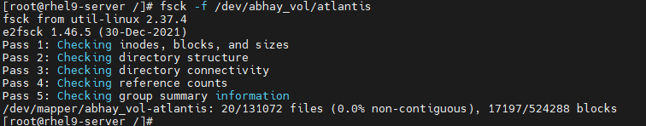

4. Run resize2fs (For ext4) to fix the final volume size for atlantis LV to 2GB

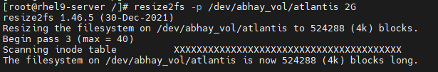

5. Finally, resize it to 2GB as shown below-

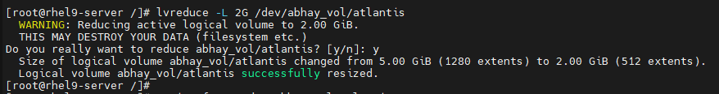

6. Again repeat step 4 for verification. It should show “Nothing to do!”-

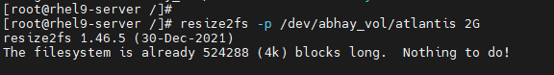

7. Repeat step 3 for file system error check-

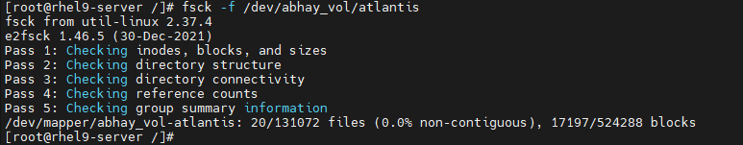

8. Again mount atlantis LV & verify it-



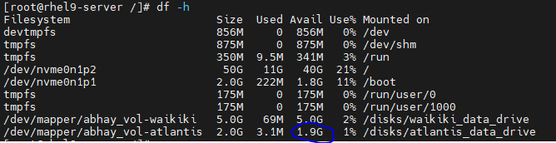

9. Check data of atlantis LV after reducing volume size-



10. Check increased volume size of volume group-

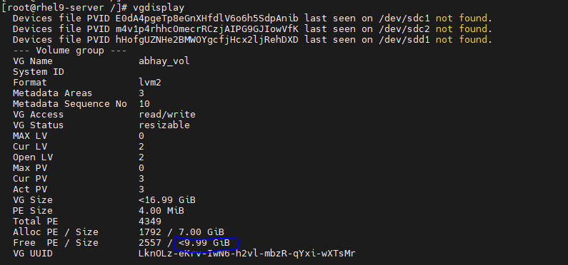

That’s it!!!!